Programming Shikhbo--YouTube Channel

HTML

Software Requirement:

1. Text Editor - (Notepad/Notepad++/VS Code/Sublime/Brackets)

suggested--VS Code

2. Browser - (Chrome/Mozilla Firefox/Internet Explorer/Edge/Safari)

suggested--Chrome

Basic Setup:

1. New Folder Create

2. Create an HTML File in this Folder

3. Fix File Extension

4. Open the Folder in VS Code

Basic Syntax Tag:

<tag>......................................</tag> 6 types of heading tags:

opening Closing h1------ Big size

ex: <h1> Hello Bangladesh </h1> h2------

or, <h1> h3------

Hello Bangladesh, how are you? h4------

Yeah, I am fine! h5------

</h1> h6------ Small size

HTML Structure:( Write to VS Code)

! --and press enter

or, html:5 --and press enter

or,

Structure

<!DOCTYPE html>

<html>

<head>

<title>HTML Practice Day 1</title>

</head>

<body>

<h1>Hey, I am Shakil Hasan. I am a Web Developer</h1>

<p> …………………………………………………………………………. </P>

</body>

</html>

HTML Text Formatting Tags:1

1) Heading

2) Paragraph ---> tag

* + - Bold <b>... </b>
    - italic <i>... </i>
    - underline <u>... </u>
    - strikethrough <del>...</del> or, <s>...</s>

HTML Text Formatting Tags:2

1. **Align-**

<h1 align=” left, right, center, justify” >

<p align=” left, right, center, justify” >

suggested -- <h1 style=”text-align: center;”>

2) **Subscript**- H2O

<sub>……………</sub>

3) **Superscript**- X2

<sup> ……………</sup>

4) **Break-** single tag

<br/>

5) **&nbsp** – space in two words or letter

&nbsp;

Style Tag:

1)Text -----Color

<h1 style=” color: color name;”>………………</h1>

<p style=” color: color name;”>………………... </p>

-----Background Color

<h1 style=” background-color: color name;”> ………………</h1>

-----Font Size

<h1 style=”font-size:100px;”> ………………</h1>

-----Font Family

<h1 style=” font-family: font name;”>… ………………</h1>

-----All in one <h1 style=” color: color name; background-color: color name; font-size:100px; font-family: font name;”>. ………………</h1>

Required Tags:

* <blockquote> = same to <p> tag, but paragraph alignment is on the right.
* <small> = for small font
* <abbr> = When the mouse pointer is up to USA short form, it will show full form.

<abbr title=” United States of America;”>…………. </abbr>

* <q> = for “ ”
* <address> = for writing address
* <cite> = same as <i> tag but, it cannot be used everywhere. It is usually used under the picture.
* **<span> = for any changes. Such as words, letters, sentences, etc.**
* <span style=” color: color name; background-color: color name; font-size:100px; font-family: font name;”>……………………... </span> **<**

Image Tag & Anchor Tag:

* <img src=” images/image name with extension” alt=” any name”/>……………single tag
* <a href=” URL Link copy paste”> ……………... </a>

For new tab <a href=” URL Link copy paste” target=”-blank”> ……………... </a>

Table Tag: (4*4)

<table border=”1” style=” border-collapse: collapse; text-align: center;” width=”700px” height=”200px”>

<tr style=” background-color: color name; color: color name;”>

<th>Rank </th>

<th>Name </th>

<th>Points </th>

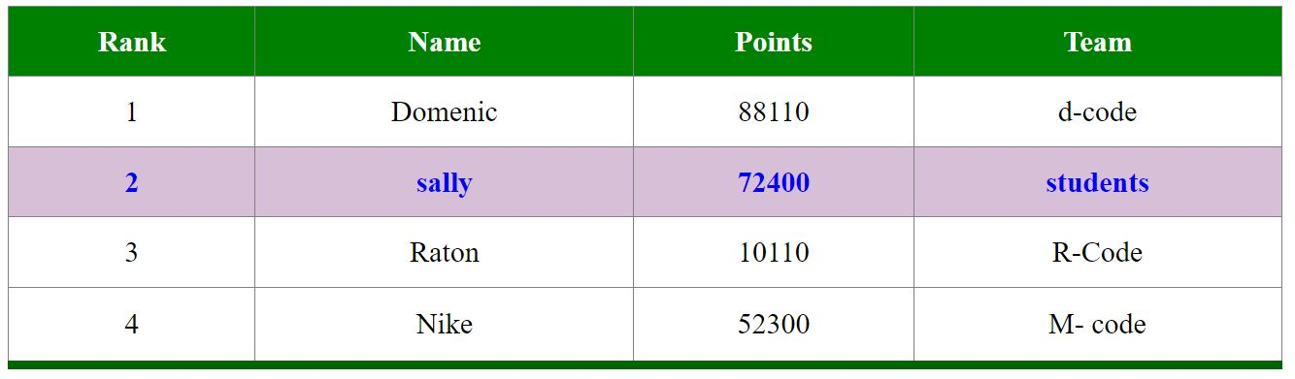 <th>Team </th>

</tr>

<tr>

<td>1</td>

<td>…………… </td>

<td>…………… </td>

<td>…………… </td>

</tr>

<tr style=” background-color: color name; color: color name; font-weight: bold;”>

<td>2 </td>

<td>…………… </td>

<td>…………… </td>

<td>…………… </td>

</tr>

<tr>

<td>3 </td>

<td>…………… </td>

<td>…………… </td>

<td>…………… </td>

</tr>

<tr style=” border-bottom: 5px solid color name;”>

<td>4</td>

<td>…………… </td>

<td>…………… </td>

<td>…………… </td>

</tr>

</table>

List Tag:

Unorder list order list

<ul> <ol>

<li>book</li> <li>book</li>

<li>pen</li> <li>pen</li>

<li>paper</li> <li>paper</li>

</ul> </ol>

Description List - <dl>

<blockquote> = same to <p> tag & <dl> tag but paragraph alignment is on the right

<dt> Bangladesh</dt>

<dd>……………………………………………………………………………………………………………………………………………

……………………………………………………………………………………………………………………………………………………

………………………………………………………………………. </dd>

Table Tag II:

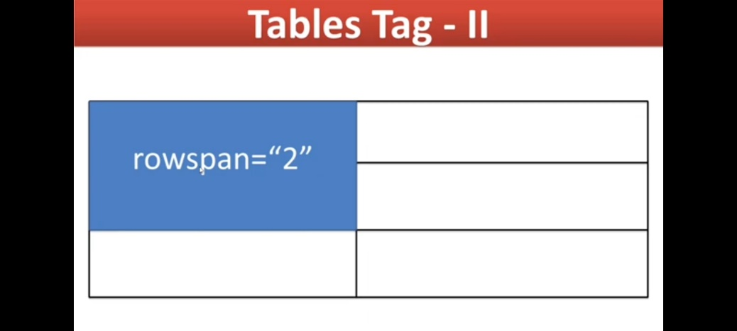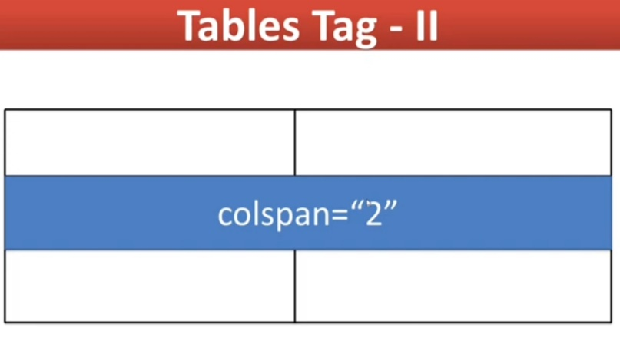

Marquee Tag:

Text motion

<marquee>……………………………………………… </marquee> = left to right motion continually (Default)

<marquee behavior=” slide”>............................ </marquee> = left to right motion & right stop

<marquee behavior=” alternate”>..............……... </marquee> = left to right motion & right to push(dhakka)

<marquee behavior=” scroll”>.............................</marquee> = left to right motion continually (Default)

<marquee scrollamount=”20”>……………………… </marquee> = left to right motion speed

<marquee direction=” right”>……………………… </marquee> = Default direction start left

<marquee direction=” up or down”>…………………… </marquee> = text motion from UP or DOWN.

<marquee onmouseover=” this.stop()” onmouseout=”this.start()”>………………… </marquee> = text motion stops and starts when the mouse pointer on the text.

<hr> or <pre> tag:

* <hr>= horizontal rule………. single tag

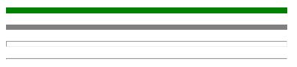 <hr width=”20%” size=”5” color=” green”>…

<hr width=”20%” size=”5” noshade>…………..

<hr width=”20%” size=”5”>…………………………

<hr width=”20%”>……………………………………...

<hr width=”20%” size=”5” color=” green” align=” right>…….. = H.R go right

* <pre>……………… </pre> = space between two words (&nbsp)

Login Form:

<form>

<input type=””>……………... =single tag

“ Text, radio, button, checkbox, email, password, color, date, datetime, datetime-local, file, hidden,

image, month, number, range, reset, search, submit, time, week, URL, tel “

</form>

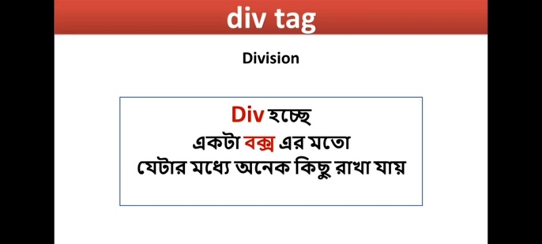Div tag:

<div>

<div>…………………………….. </div>

<div>…………………………….. </div>

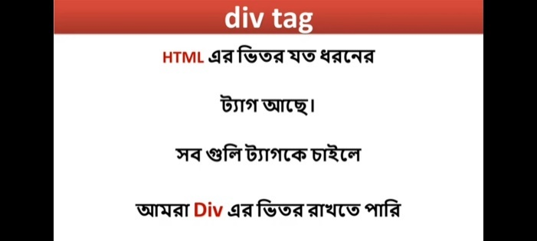 <div>…………………………….. </div>

</div>

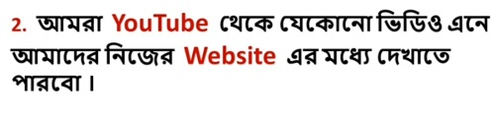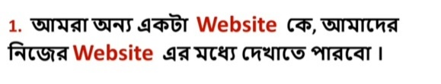iframe Tag:

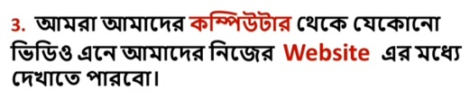<iframe src=””>…………….. </iframe>

Video Tag:

<video src=” …...” width=” …px “ controls autoplay loop poster=” …. “> </video>

Or,

<video width=” …px “ controls autoplay loop poster=” …. “>

<source src=” …... “ type=”video/mp4”>

</video>

Audio Tag:

<audio src=” …... “ type=”audio/mp3” controls autoplay loop preload=”none”> <audio>

preload=” metadata”

preload=” auto”

Or,

<audio controls autoplay loop >

<source src=” …... “ type=”audio/mp3”>

</audio>

span Tag:

* **<span> = for any changes. Such as words, letters, sentences, etc.**

<span style=” color: color name; background-color: color name; font-size:100px; font-family: font name;”>……………………... </span>

HTML Entities:

&lt; = < (less then) ;

&gt; = > (getter then)

<https://www.w3schools.com/html/html_entities.asp>

<https://tools.w3cub.com/html-entities>

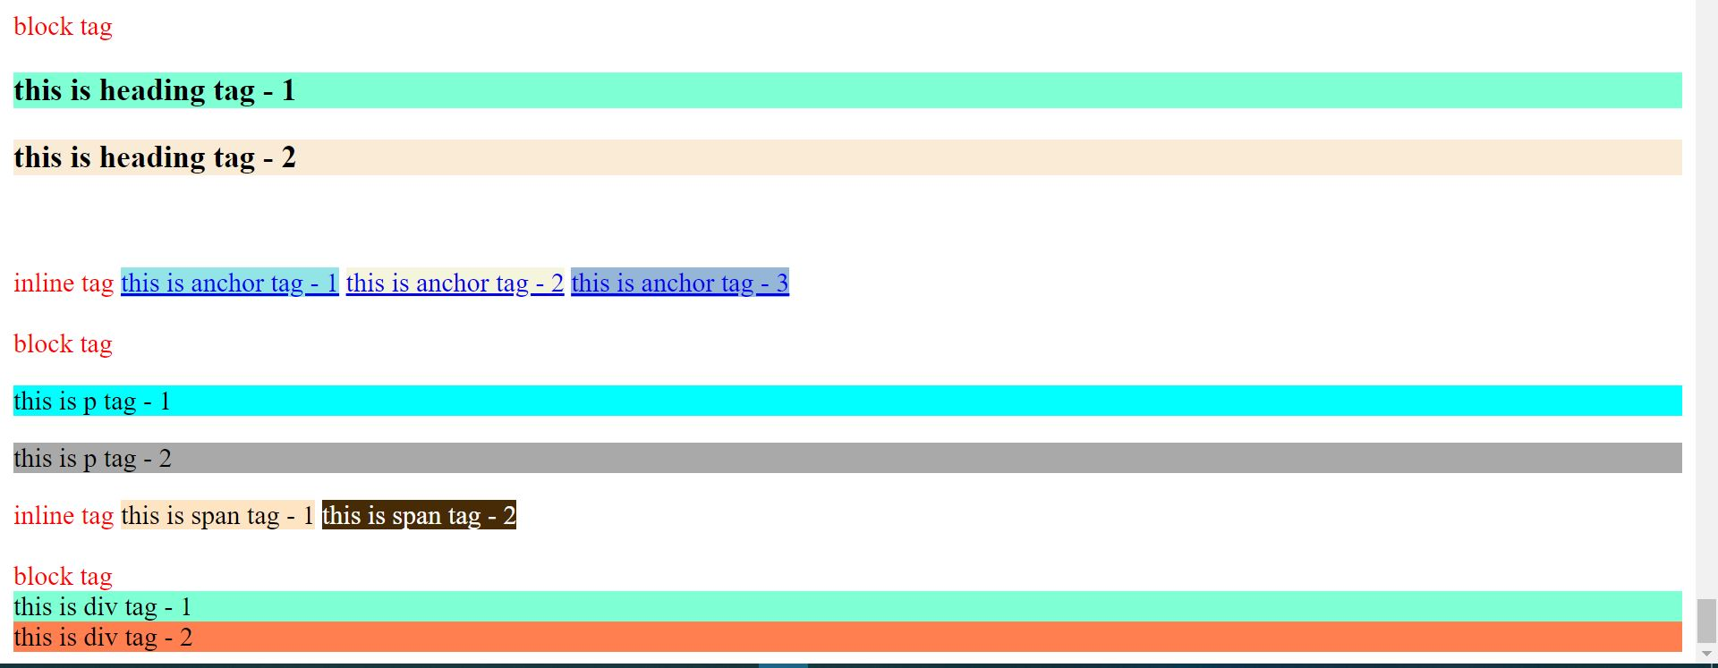Block & inline Tag:

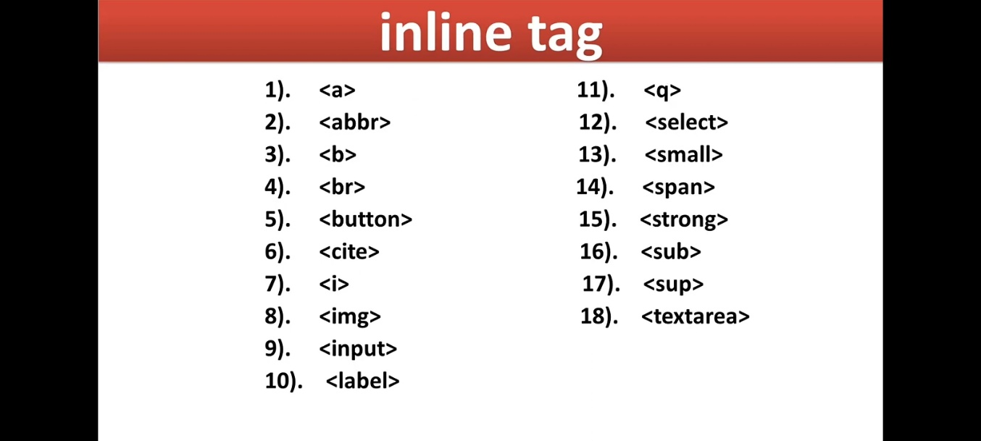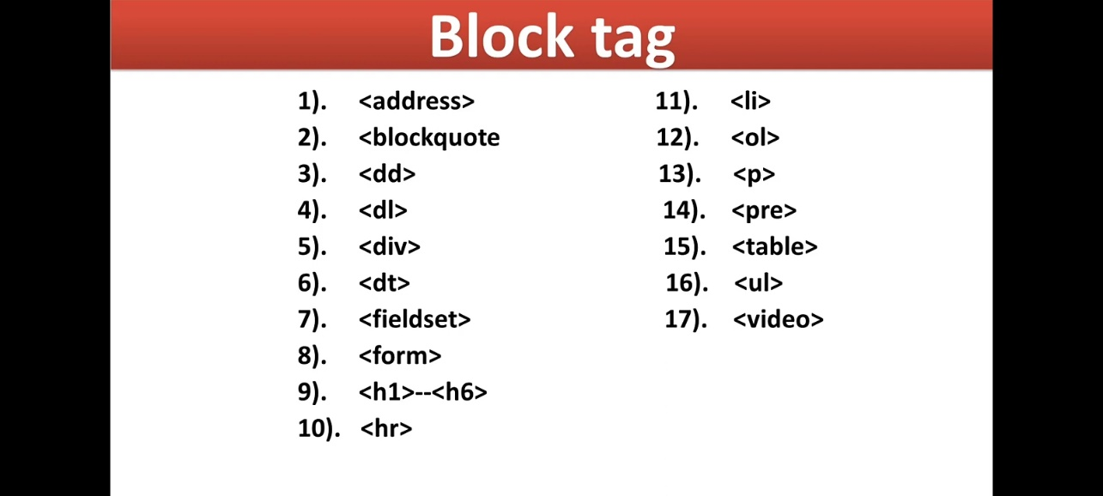

Revision All HTML Tag